SOP – Staging server for Repository management for patching

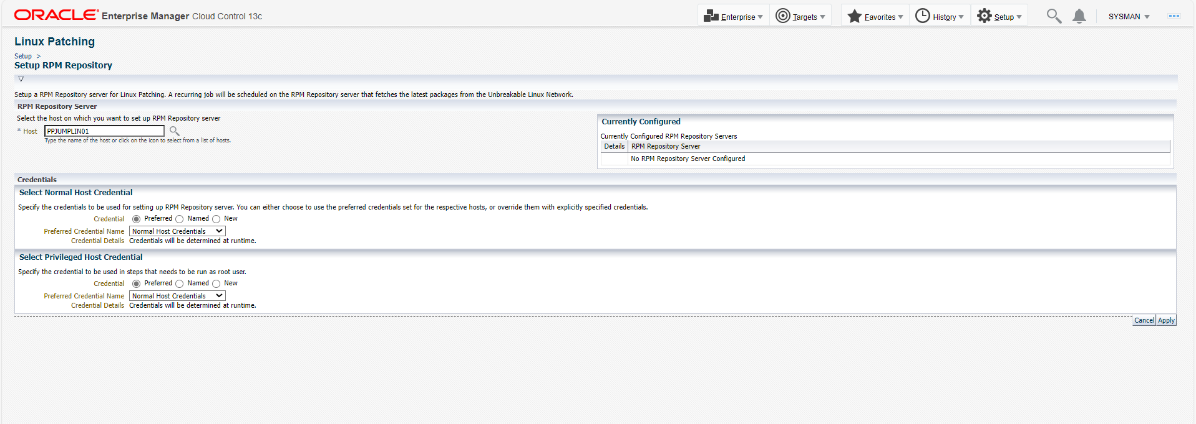

Stage Server Selector
The Software library by default contains the latest version of up2date for Red Hat Enterprise Linux 4, i386 hardware platform. If the RPM Repository Server is of a different release version or architecture (use uname -p on your system to identify the architecture), download the appropriate version of "up2date" and "up2date-gnome" packages from the link http://linux.oracle.com/switch.html. Compress these two packages by using Zip utility into a file named "up2date_comp.zip" and replace it in the Software Library location, "Components > Oracle Components > Stage Server Up2date Component > 10.2.0.4.0 > Linux > UP2DATE_RPM". Click on the following link to access the component in Software library

imp-ppjumplin01.itc.local https://imp-ppjumplin01.itc.local:3872/emd/main/

